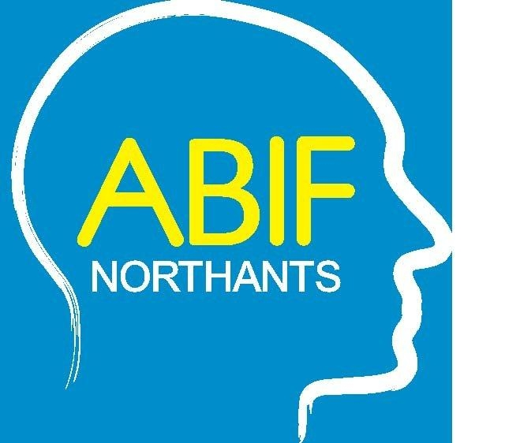

Northamptonshire Acquired Brain Injury Forum

“Advance Decisions ?...?
What does it mean for treating / supporting your brain injured client”

A presentation by Advance Decisions Assistance
http://adassistance.org.uk/

Tuesday 20th November 2018 at 2.00 pm

Park Inn by Radisson, Silver Street, Northampton, NN1 2TA
(free car parking available, register your car at Reception)

Charge £10 per person

Tea and coffee provided: Doors open from 1.30 pm
For further information, or to make a booking, please Email: events@abifnorthants.com or visit the ABIF Northants website: www.abifnorthants.co.uk

